What is the Excretory System?
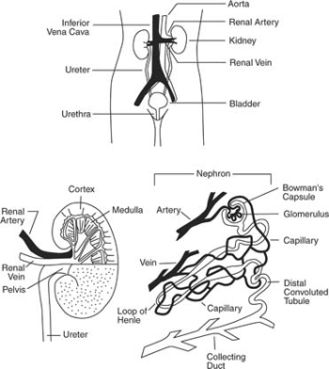
The excretory system is the system that isolates (to set apart) and discharges (to empty) waste generated during metabolism (the set of chemical reactions that happen in the cells of living organisms to sustain life).
Excretory System Video Clip:
http://player.discoveryeducation.com/index.cfm?guidAssetId=4B03BBE4-95D4-44AB-A42C-91A59F269B8F&blnFromSearch=1&productcode=US

Excretory System Reading (Blue – Science Explorer Text) pages D145-D150

Excretory System Diagram

