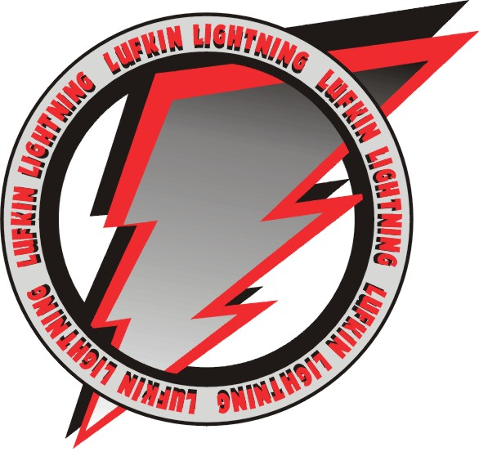

Lufkin Road Middle School

1002 Lufkin Road    Apex, NC 27539

Phone: (919) 387-4465 Fax: (919) 363-1095

LRMS Science Safety Contract
Prior to the Lab Activity-Preparation
- Hair should be tied back if requested by the teacher or the lab activity.
- No opened toed shoes, loose fitting clothes, or hanging jewelry in lab.
- Read all lab directions and ask questions if unclear.
- Students should clear lab area of all unnecessary materials and supplies.
- Wear goggles as directed by the lab activity and teacher in situations using chemicals and sharp objects.
- Student and parent must sign safety contract. Student must keep a copy of the rules in their notebook.

During the Lab Activity-Equipment, Behavior, Group Work, Accidents
- Use only authorized equipment (permission) when directed to do so by teacher.
- Do not perform unauthorized (without permission) experiments.
- Smell chemicals using the proper “wafting” technique.
- Do not taste, touch, smell, or drink chemicals unless directed by teacher.
- Electricity and water do not mix.
- No food, beverages or gum in the lab unless directed by teacher.
- Students should work as a group and be considerate and respectful of each other.
- Students should stay within their group during experiments and activities.
- Read and follow procedures and safety rules for each lab activity.
- No horseplay-(running, jumping, pushing, and shoving).
- Treat animals with respect.
- Do not sit on counters or tables.
- Report all accidents immediately to the teacher.
- Know where to find safety equipment such as the eyewash and fire extinguisher.
- Deliberate (on purpose) breakage will be charged.

After the Lab Activity-Clean Up
- Return all supplies to proper area.
- Dispose of waste and glass in the correct area or containers.
- Wipe up all spills immediately.
- Wash hands with soap and water if necessary.

Consequences (To be set by teacher in the Science Room)
- Sit out lab for deliberate breakage, rough play, harming others or any failure to follow directions.
- Alternative assignments.
28.Lab license revoked.
29.Lightning Strikes added to team notebook.
30.Note to parent in agenda or email.
31.Office referral to grade level administrator.

Students should keep this copy of the rules in their science notebook all year. The “Agreement” is to be signed and returned to the science teacher.

Agreement

I have read and agree to follow all the safety rules set forth in the LRMS safety contract, I realize that I must obey these rules to insure my own safety, and that of my fellow students and instructors. I will cooperate to the fullest extent with my instructor and fellow students to maintain a safe lab environment. I will also closely follow the oral and written instructions provided by the instructor. I am aware that any violation of this safety contract which results in unsafe conduct in the laboratory or misbehavior on my part my result in the lab consequences stated above or other appropriate disciplinary measures.

______________________________ ________________________
Student Signature Date

Dear Parent or Guardian:
We feel you should be informed regarding the school’s effort to create and maintain a safe science classroom/laboratory environment. With the cooperation of the instructions, parent, and students safe lab practice can prevent, correct and eliminate possible hazards. Please review the list of safety rules. No student will be permitted to perform laboratory activities unless the LRMS safety contract is signed by both the student and the parent/guardian and is on file with the instructor. Your signature indicates that you have read the Lufkin Road Middle School Safety Contract, are aware of the measures taken to insure the safety of your son/daughter in the science laboratory, and will instruct your son/daughter to uphold his/her agreement to follow these rules and procedures in the laboratory.

_______________________________ __________________________

Parent/Guardian Signature Date

