The Circulatory System
Guided Notes
- List four jobs that our circulatory system does:
  - Brings blood containing _______________________________________________________to cells
  - Transports _______________________________________________________ from cells
  - Fights _______________________________________________________
  - Regulates _______________________________________________________
- Heart:
  - A _______________________________________________________
  - Moves __________________________________________________through the _______________________________________________
  - Has _______________________________________________________ chambers
  - _______________________________________________________into _______________________________________________________and _______________________________________________________
  - Made up of _______________________________________________________ cells
- Heart Chambers:
  - Atria- (2) _______________________________________________________chambers
    - _______________________________________________________walled
    - Receive ___________________________________________________from ___________________________________________________
    - Send ___________________________________________________to ___________________________________________________
  - Ventricles- (2) _______________________________________________________chambers
    - _______________________________________________________walled
    - Receive ___________________________________________________from ___________________________________________________
    - Pumps ________________________________________________through ________________________________________________
  - Septum: _____________________________that divides __________________________into right and left ______________________
- Label the Diagram of Structures of the Heart
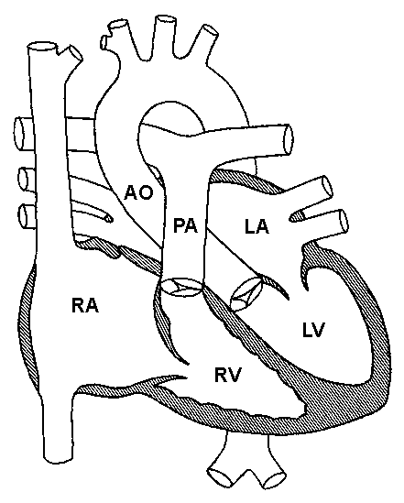
- Blood Vessels:
  - Form a _____________________________________________circuit of ______________________________________________that carry blood throughout the______________________________________________
  - Laid end to end, the blood vessels in an average human body will stretch approximately 62,000 miles or ___________________ times around the earth.
- Blood Pressure:
  - Blood pressure refers to the _______________________________________________________exerted by circulating _____________________________________________on the ______________________________________________of blood _____________________________________________
  - The pressure of the circulating blood _______________________________________________________as blood moves
  - Blood pressure is most commonly measured via sphygmomanometer (or blood ____________________________)
  - Average blood pressure for an adult is _______________________________________________________
- A person's pulse is the _______________________________________of their _______________________________________as an effect of the _______________________________________waves (heart beat)
  - Pulse is used to denote the _______________________________________________________of the heart beat
  - It can be felt at neck, __________________________________________________and other places
  - Pulse is usually measured in _________________________________________per _________________________________________
- Blood:
  - A circulating __________________________________________tissue consisting of several types of ____________________________________suspended in a _____________________________________ known as plasma.
- Functions of blood:
  - Supply _______________________________________________________to tissues
  - Supply _______________________________________________________such as glucose, amino acids and fatty acids
  - Removal of _______________________________________________________such as CO² , urea and lactic acid
- Composition of Blood:
  - What percent of your body is blood? _______________________________________________________
  - How much blood do we contain? _______________________________________________________
  - What percent of your blood is cellular? _______________________________________________________
  - What percent of your blood is plasma? _______________________________________________________
  - What is plasma? _______________________________________________________
  - What percent of plasma is water? _______________________________________________________
  - What’s in plasma? _______________________________________________________
  - Blood cells are formed in _______________________________________________________
  - Red blood cells are ___________________________________ in size and live ___________________________________ days
  - White blood cells ___________________________________ in size and live ___________________________________ days. When you are ___________________________________, you have more white blood cells.
- List eight circulatory system disorders and a fact about each one.

