Cell Hierarchy Activity
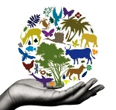
Objective: Students will review and illustrate the progressive hierarchy of multicellular organisms from cells to tissues to organs to organ systems to organisms.
Procedure:
- Choose a plant or animal. Be specific. For example, an Oak Tree or a Polar Bear.
- Depict how this organism goes from a cell to the organism itself in an increasing fashion. You will have to follow one cell type → one tissue type → one organ → one organ system → organism.
- Draw and label each different level of your plant/animal cell (cell, tissue, organ, organ system, and organism). Use the assignment “Cells R Us” in your Science NB as a guide.
- Color your final product and be prepared to share before you turn it in.

